SWEET POTATO CHICKPEA BUDDHA BOWL

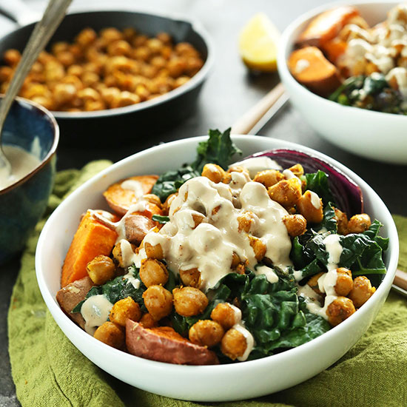

Flavorful, filling, 30-minute Buddha Bowl with roasted sweet potatoes, onion, kale, crispy chickpeas and an AMAZING tahini-maple sauce! A healthy, satisfying plant-based meal.
Author: Minimalist Baker
Recipe type: Entree
Cuisine: Vegan, Gluten Free
Serves: 2-3
Ingredients
VEGETABLES
- 2 Tbsp olive, melted coconut, or grape seed oil
- 1/2 red onion, sliced in wedges
- 2 large sweet potatoes, halved
- 1 bundle (227 g) broccolini, large stems removed, chopped
- 2 big handfuls kale, larger stems removed
- 1/4 tsp each salt + pepper
CHICKPEAS
- 1 15-ounce (425 g) chickpeas, drained, rinsed + patted dry
- 1 tsp cumin
- 3/4 tsp chili powder
- 3/4 tsp garlic powder
- 1/4 tsp each salt + pepper
- 1/2 tsp oregano (optional)
- 1/4 tsp turmeric (optional)
TAHINI SAUCE (OPTIONAL)
- 1/4 cup (56 g) tahini
- 1 Tbsp maple syrup
- 1/2 lemon, juiced
- 2-4 Tbsp hot water to thin

Instructions
- Preheat oven to 400 degrees F and arrange sweet potatoes and onions on a bare baking sheet. Drizzle both with a bit of oil, making sure the flesh of the sweet potatoes are well coated and placed skin side down on the sheet.
- Bake for 10 minutes, then remove from oven flip sweet potatoes and add broccolini. Drizzle broccolini with a bit of oil and season with a pinch each salt and pepper.
- Bake for another 8-10 minutes, then remove from oven and add kale. Drizzle kale with a touch more oil and season with a pinch each salt and pepper. Bake for another 4-5 minutes then set aside.
- While vegetables are roasting, heat a large skillet over medium heat and add chickpeas to a mixing bowl and toss with seasonings.
- Once hot, add 1 Tbsp oil and chickpeas and sauté, stirring frequently. If they’re browning too quickly, turn down heat. If there isn’t much browning going on, increase heat. I found 10 minutes total at slightly over medium heat was perfect.
- Once the chickpeas are browned and fragrant, remove from heat and set aside.
- Prepare sauce by adding tahini, maple syrup and lemon juice to a mixing bowl and whisking to combine. Add hot water until a pourable sauce is formed. Set aside.
- To serve: Slice sweet potatoes into bite size pieces. Divide vegetables between 3 serving bowls and top with chickpeas + tahini sauce.
- Best when fresh, though leftovers will keep for a few days in the fridge.

